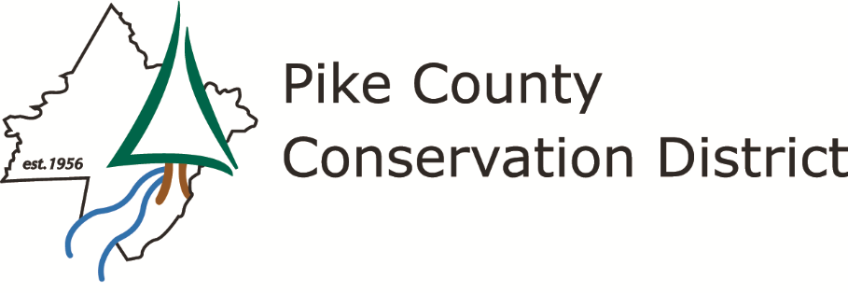

AGENDA

Monday, November 14, 2022 – 9:00am
Pike County Conservation District office, Route 402, Hawley, PA
Pike County Conservation District is committed to the long-term protection and sustainable
use of Pike County’s natural resources.
We accomplish this through partnership, education, technical assistance,
planning, enforcement, and leadership.
Meeting will be held via Zoom & in person – see email and website
I Call to order – Pledge of Allegiance – Introductions

II Public Comment on Agenda Items

III Action on Minutes of October 17, 2022 meeting (vote)

IV Financial Report (review/file subject to audit)

V Correspondence Report

VI Executive Director Report

VII OLD BUSINESS/Committee Reports
- Communication and Outreach Committee meeting

VIII NEW BUSINESS
- USGS Presentation on the Groundwater Well Level Monitoring program – Lisa Senior, USGS
- Resolution 2022-01 – Approval of the Groundwater Well Level Monitoring Report – Rachael Marques, Watershed Specialist
- 2023 Education and Outreach Plan – Devan George, Communications Coordinator
- PCCD Draft 2023 Budget – Michele Long, Executive Director
- Agriculture Conservation Assistance Program – Michele Long, Executive Director
- Palmyra Township Low Volume Road Contract Amendment – Bartleson Road – Ellen Enslin, Program Manager
IX PACD Update

X Cooperating Agency and Other Organization Reports

XI Public/Press Questions

XII Executive Session

XIII Adjourn

NEXT MEETING: MONDAY, December 19, 2022 at 9:00am

