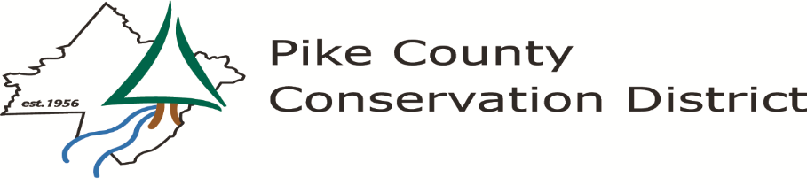
556 Route 402, Hawley, PA 18428
Phone (570) 226-8220 Fax (570) 226-8222 e-mail: pikecd@pikepa.org www.pikeconservation.org
PIKE COUNTY CONSERVATION DISTRICT BOARD OF DIRECTORS MEETING MINUTES
Monday, March 15, 2021
As a result of the COVID-19 outbreak and recommendations from the Center for Disease Control, Pennsylvania Department of Health, and the Pike County Commissioners to avoid in-person meetings the Board of Directors meeting was held via Zoom Video Conference call. Information regarding the conference call was posted on the District website.
ATTENDANCE – Directors: Commissioner Ronald Schmalzle, Scott Savini, Jay Morrow, John Milliken, Kelly Stagen, Ken Coutts Associate Directors: Joann Rose, Staff: Michele Long, Rachel Posavetz, Ellen Enslin, Chris Ingulli, Jeremy Oettinger, Marianna Quartararo, Devan George, Kelly Rodemich. Cooperating Agency Representatives: Jen Matthews (NRCS), Emily Borger (PA Waterways Conservation Officer), Matt Deitrich (PA Waterways Conservation Officer) Directors/Associate Directors Absent: Mike Spencer, Paul Ranello, Carole Linkiewicz Guests: Jim Andre
Scott Savini called the meeting to order at 9:00 am via Zoom Video Conference Call.
PUBLIC COMMENTS / QUESTIONS AGENDA ITEMS: None
ACTION ON MINUTES OF February 22, 2021: Jay Morrow made a motion to approve the February 22, 2021 Board Meeting minutes. Kelly Stagen seconded. Motion carried.
FINANCIAL REPORT: Michele explained that there was not much new activity. The Dirt and Gravel Road advancement to Palmyra Township for the Old Greentown Road project has been sent out. The board had no questions regarding the financial report. Filed subject to audit.
CORRESPONDENCE REPORT: The following correspondence was distributed to the Board prior to the meeting; Letter to Secretary Noe Ortega Department of Education regarding proposed changes to science education standards, Email regarding Delaware River Basin Commission News Release 2/25/21, The February Joint Legislative Conservation Committee Newsletter, Thank You email from Jim Andre regarding staff assistance, Email regarding PA DCNR Delaware Forest 2021 District Activity Plan, Email from Gene Schultz regarding Lacawac Sanctuary Meet a Scientist, featuring Rachel Posavetz.
EXECUTIVE DIRECTOR REPORT: Michele explained that the District has two upcoming programs. The Leaf Pack Program will be held on April 6, 2021 and the Contractor’s Workshop will take place on March 23, 2021.
Michele shared a map of the Spotted Lanternfly quarantine areas. Pike County is now included on the map. She expects to have a lot of activity in the near future. When more information is available, she will pass it along. John Milliken asked if Spotted Lanternfly is only occurring in the Southernmost part of the County. Michele explained that there is a swath in the Shohola area that has been identified.
The state has a new Harmful Algal Blooms (HABS) website. Michele will include that information in the next board packet. Currently there is not a lot of information on the website.
OLD BUSINESS/COMMITTEE REPORTS: There was no old business to discuss.

NEW BUSINESS:
PCCD Executive Committee addition – Scott asked the Board if they would be in favor of adding Treasurer Jay Morrow to join the Executive Committee. At times, financial information is discussed and having Jay on the committee would be beneficial. Ron, John and Michele supported the idea and Jay has graciously accepted. Ron thanked Jay for stepping up and supporting the District. Michele clarified this is an option as defined in our District Board Operating Procedures. Kelly Stagen made a motion to approve. Ron Schmalzle seconded. The motion carried.

2020 Annual Report - The Pike County Conservation 2021 Annual Report You Tube video was viewed. Michele stated that Devan George did an incredible job putting it together with input from all staff members. The District had good video coverage from some of our 2020 programs that we were able to include. Promoting the annual report will be similar as to how we have done it in the past, however, with it now being virtual we hope it will gain more traction as opposed to a paper copy. Kelly Stagen mentioned that the video is a tremendous representation of the work we do at the District and feels Devan and the staff did a great job. Ron Schmalzle also mentioned that Devan did a great job. Some good has come out of a bad year and we now have new ways to communicate. This is an example of Michele’s exceptional leadership in pushing forward.

PACD Update: Kelly Stagen mentioned there was nothing new to report. The next regional meeting is scheduled for April 16, 2021 and will be held virtually. All are welcome to attend.
Cooperating Agency and Other Organization Reports:
NRCS - Jen Matthews from NRCS reported they are in the home stretch of ranking applications and hope to have an indication soon as to where funding will go. A mailing was sent out by the Game Commission regarding Grouse habitat. NRCS does have funding for Grouse habitat if anyone is interested.
PA Fish and Boat Commission – Matthew Dietrich explained that stocking in Pike County creeks and lakes has begun and will continue for the next several weeks. The youth mentor program is scheduled for March 27, 2021 and the State-wide trout opening day is April 3, 2021.
Executive Session: An executive session was not held.
PUBLIC/PRESS QUESTIONS: Jim Andre stated that the emails he had sent to Michele were heartfelt and the staff is very helpful and intelligent. He feels that the District message is incredible and positive. Scott added that we have a special team and the good work we do starts with Michele’s leadership.
Jay Morrow mentioned that he was disappointed to see that State Representative Lisa Baker is heading up a lawsuit to overturn the fracking ban developed by the Delaware River Basin Commission. He asked if the District planned to oppose her view. The District is not going to provide comments at this time.
ADJOURN: Kelly Stagen made a motion to adjourn the March 15, 2021 Board of Directors Meeting. Jay Morrow seconded. Motion carried. Meeting adjourned at 9:42 am.
Respectfully submitted, Kelly Rodemich, Board Secretary.

